NEWS RELEASE
FOR IMMEDIATE RELEASE
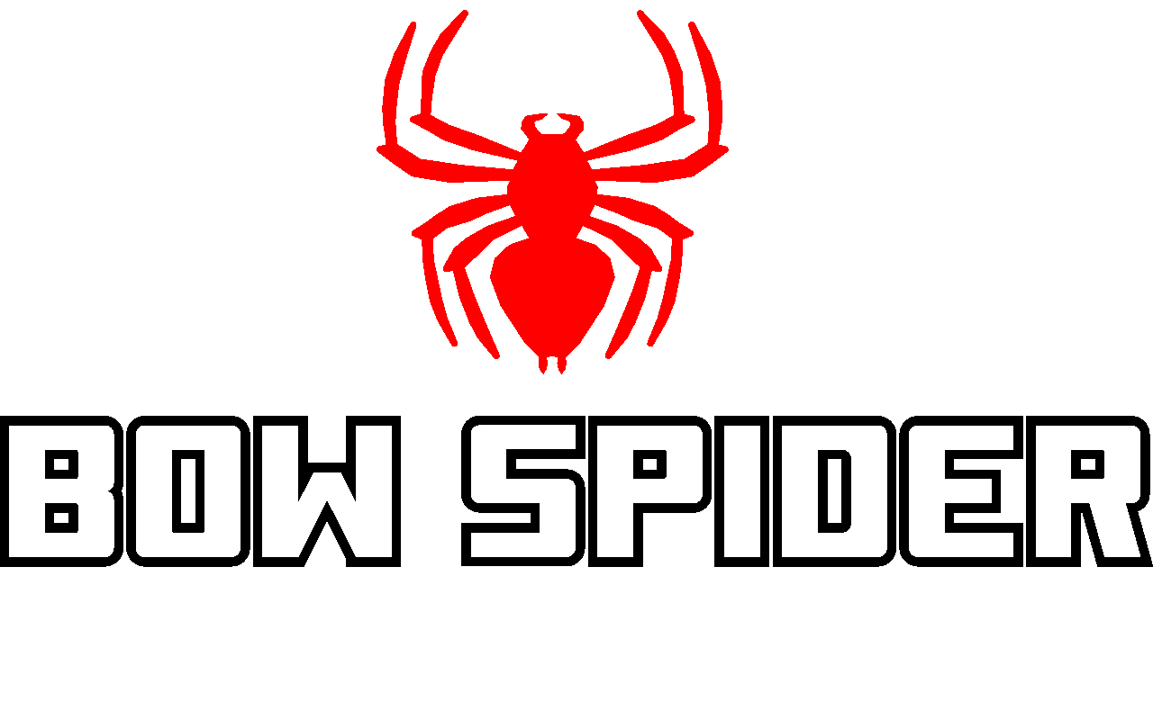

Bow Spider Film Makes It into Western Hunter Magazine
Film Festival Finals

KINNEAR, Wyo.(Nov. 29, 2021) — David Merrill owner of Bow Spider, the quickest and easiest bow retrieval system on the market, is pleased to announce that his first film, “A Day in the Brooks” has made it into Western Hunter Magazine’s film festival finals. This 44-minute film chronicles he and his 65-year old father’s Alaskan Dall sheep adventure. It is one of five films in the Professional Long category. The other three categories in the film festival include Professional Short, Amateur Long and Amateur Short.

"We are very honored to have been selected for the festival,” said Merrill. “This film is near and dear to my heart as it will be one of the final adventures in the Brooks Range with my dad. I hope everyone enjoys watching it as much as we enjoyed capturing and creating it. Never miss the moment. Grab your bow and go!"

A panel of industry judges was carefully selected to determine the category finalists. With the finalists determined voting has now gone to the public. Anyone is eligible to vote for their favorite film in each category. To view the films and to register to vote visit: https://filmfest.westernhunter.net/ or CLICK HERE.

"We started the Western Hunter Film Festival to give talented amateur and professional film makers a platform to present their work.,” said Chris Denham, marketing director and co-owner of Western Hunter Magazine. “ I was especially excited to see the shows submitted in the professional long category, knowing there would be some incredible stories. "A Day in the Brooks" along with the other four finalists is everything I hoped to see!"

About Recreational Archery Development LLC (RAD, LLC):
Founded in 2019 and headquartered in Kinnear, WY, RAD, LLC is a leading designer and manufacturer of innovative products for the outdoor industry, including the Bow Spider brand of products. Bow Spider’s intuitive design makes bow retrieval fast and easy in any situation. The product is proudly made in the USA and gives one percent of all sales to conservation. The company also offers veterans a 15 percent discount on all products. (To take advantage of this offer, orders need to be called in directly to the company at 307-438-9290.) For additional information on RAD, LLC and the Bow Spider brand of products write to: RAD, LLC, PO Box 171, Kinnear, WY 82516; call 307-438-9290; email info@bowspider.com; visit www.bowspider.com.

Editorial Contact:
Karen Lutto
210-451-9113 (office)
804-539-6699 (cell)
karen@hunteroc.com
HOC Website: www.hunteroc.com

