NEWS RELEASE
FOR IMMEDIATE RELEASE
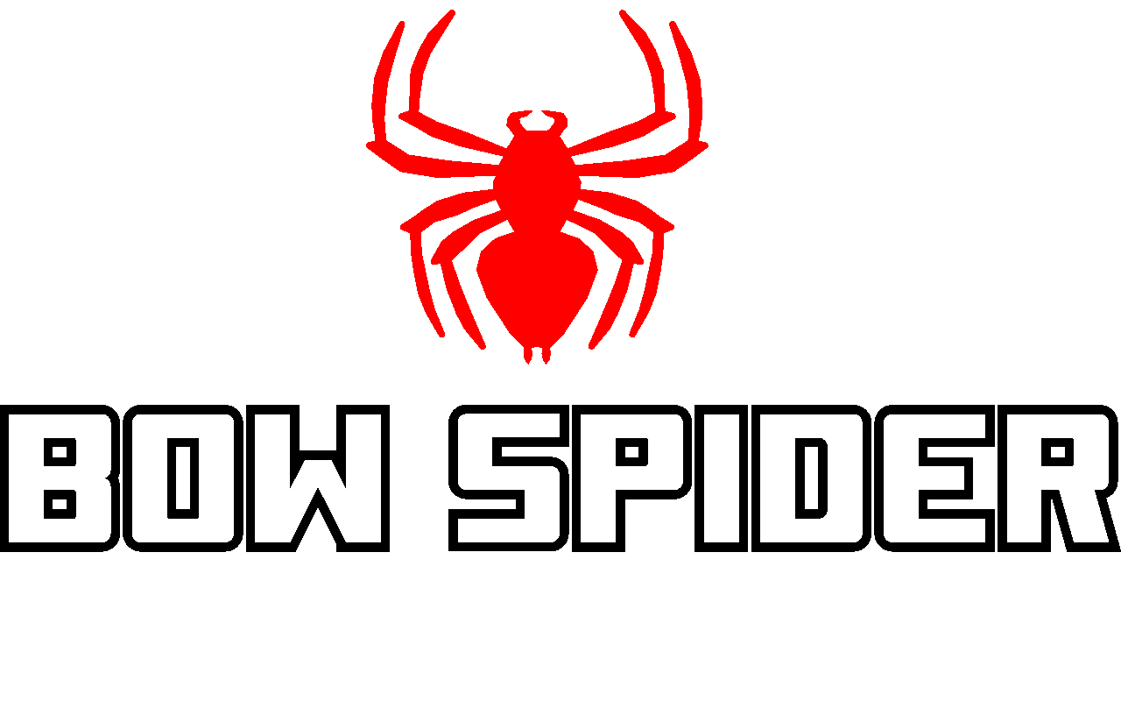
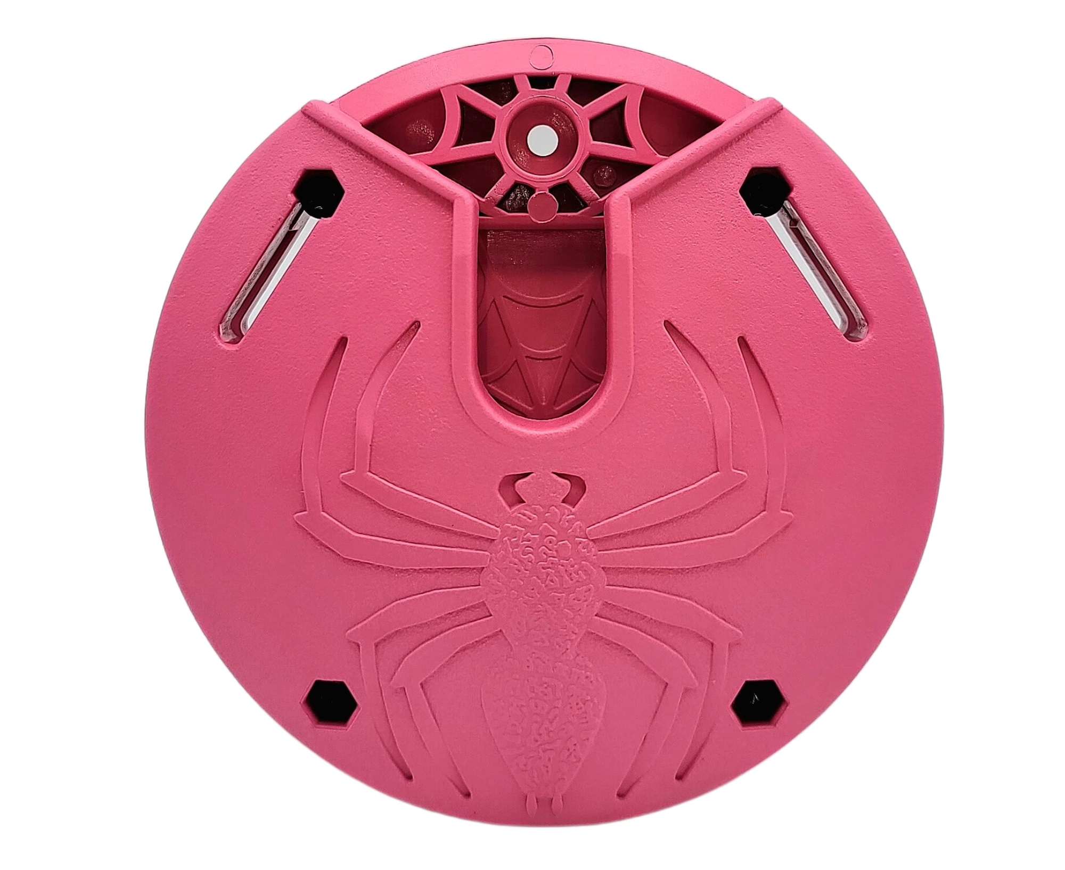

Pink Pucks Are in Stock and Shipping

Kinnear, WY (May 9, 2023) — Bow Spider, the quickest and easiest bow retrieval system on the market, is pleased to announce that the popular pink Bow Spider puck is now in stock and shipping. Originally launched in April 2021 as a limited run, the pink puck quickly gained popularity. Unfortunately, it quickly sold out and due to supply chain issues, the company was unable to keep producing it. All issues have now been resolved and the pink is back in stock.

Adding the pink puck back to the line is a continued effort to fulfill customer requests. “We continually received orders and requests for the pink puck,” said David Merrill, president and owner. “We listen to our customers and want to make sure they are happy.”

Currently in-stock and shipping, the complete pink Bow Spider packing system retails for $89.95 and an individual receiver or 2-Pack of receivers retails for $34.99 and $59.95 respectively. The Bow Spider is also available in black, tan and green. Additional colors will be added to the lineup in the coming months. Be sure to check the website regularly at www.bowspider.com for the latest news.

The Bow Spider concept is simple and revolves around a lightweight, roundish bow holder that comes with a sturdy belt and long bolts, allowing for multiple ways to secure your bow. An aluminum arm attaches to the bow’s riser, and slides into a slot on the lightweight, injection-molded receiver, which can be worn on the included belt or attached via long bolts to other objects. The bow is held securely in place via a gravity-locking system yet slides out with minimal effort. You have to either pull it out or turn it upside down to get the bow out. Use the belt to attach your bow to your pack, hip, truck headrest, blind, or tree. Bow Spider can also be easily attached to a binocular harness or backpack. In fact, it can be mounted to any sturdy ﬂat surface for secure and easy storage – even a wall.

To order your pink Bow Spider now Click Here. You will want to get your pink Bow Spider while you can. This is a limited run and won’t be around forever.

About Recreational Archery Development LLC (RAD, LLC):
Founded in 2019 and headquartered in Kinnear, WY, RAD, LLC is a leading designer and manufacturer of innovative products for the outdoor industry, including the Bow Spider brand of products. Bow Spider’s intuitive design makes bow retrieval fast and easy in any situation. The product is proudly made in the USA and gives one percent of all sales to conservation. The company also offers veterans a 15 percent discount on all products. (To take advantage of this offer, orders need to be called in directly to the company at 307-438-9290.) For additional information on RAD, LLC and the Bow Spider brand of products write to: RAD, LLC, PO Box 171, Kinnear, WY 82516; call 307-438-9290; email info@bowspider.com; visit www.bowspider.com.

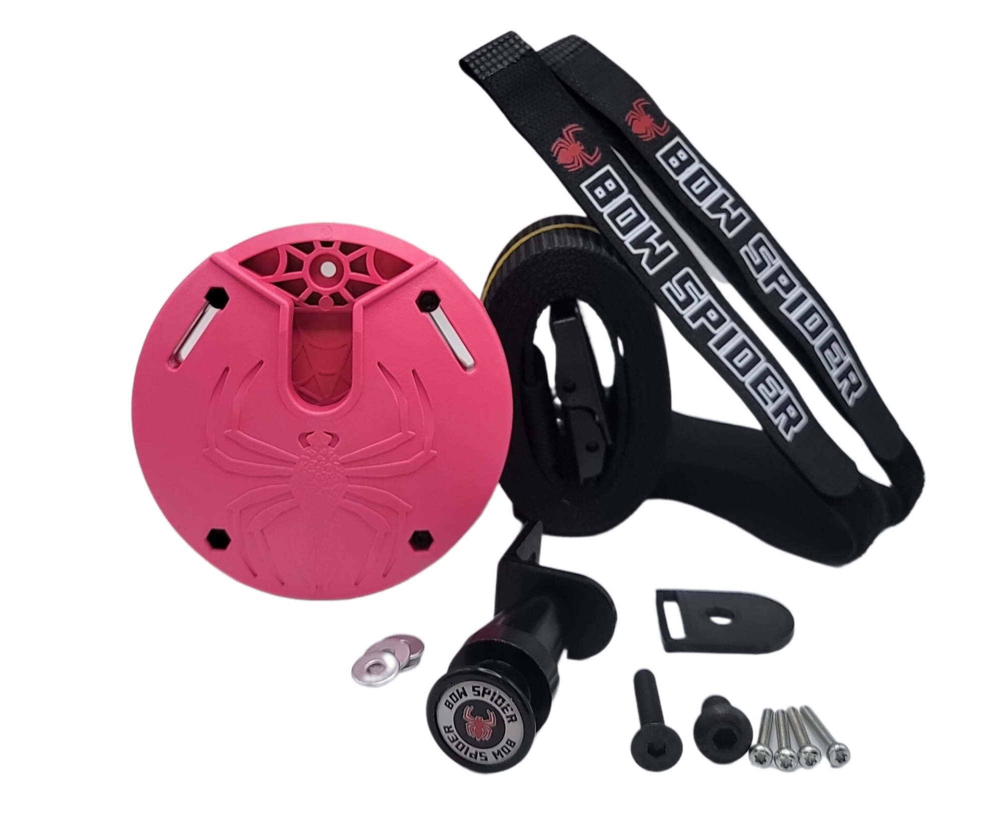
Editorial Contact:
Karen Lutto
210-451-9113 (office)
804-539-6699 (cell)
karen@hunteroc.com
HOC Website: www.hunteroc.com

